Schneider Department: | AOCI | Document Identification: | AOCI/PMP/RE/T/7
Project Code: | Xxxxxx
Mass Software Upgrade (MSU)

Executive definition & objectives: It is the expression and formalization from the customers needs into offer requirements. It corresponds to customer needs to which we have decided to answer. It is the project reference that becomes the commitment of the project team.

Note: the offer is material or immaterial. It includes product, equipment, solutions, systems, and services, provided by the company to satisfy the customer needs. The retained requirement should be associated to a validation; therefore it should be measurable and controllable.

Deliverable Name | Offer Requirements | Stage Gate
Deliverable Name | Offer Requirements | OPEN
Deliverable Name | Offer Requirements | SELECT
Deliverable Name | Offer Requirements | DO
Deliverable Name | Offer Requirements | IMPLEMENT
Deliverable Name | Offer Requirements | PRODUCE
Deliverable Name | Offer Requirements | SELL
Deliverable Name | Offer Requirements | CLOSE

Status | Draft | In Review | Official

Roles | Function | Name
Authors
Reviewers
Approvers
Refer to applicable Roles Assignment List to fill this table

Template Revision History
Version | Date  dd/mm/yyyy | Author(s) | Modification Details
1.0 | 01/07/2010 | AOCI Quality

Document Revision History
Version | Date  dd/mm/yyyy | Author(s) | Modification Details
00.00 | 20/07/2014 | Pawan Modi | Initial Draft
V1.0 2008/03/18 J.Templeton Fist Official Version Embed final feedback file for Official versions

Linked Documents
Name | Reference | Author | Comments

Show hidden text to read the help (click on standard tool bar command: ¶)

General guidelines to elaborate this document

1. Tailoring the template:
- The template scheme and proposed content intend to help the author in the elaboration of the document: they match our processes definition and way of work and should apply well in most cases.
- Nevertheless, the author has to adapt the proposed content in case of specificities. When some proposed chapters are not applicable, the recommendation is to keep them inside the final document with a short justification of the inapplicability. When extra information is needed, the author is encouraged to structure and document it in the most convenient way.
- In any cases, filling a document rigorously respecting its template is not an objective in itself. It is preferable to reach the intended goal and function of the document than to fit to an inappropriate template scheme.
- A document is appropriate for its intended use if it is:
- Complete: each expected content is present
- Correct: each content is exact
- Consistent: the document fits other related data

2. Updating automated fields:
- Three automated fields must be updated by the author (menu ‘File-Properties-Summary tab):
- The field ‘Title’ is used for the ‘Project Name’
- The field ‘Subject’ is used for the ‘Deliverable Name’ (ex.: “Project Management Plan”, “CANopen Field Bus Product Specification”)
- The field ‘Comments’ is used for the ‘Version’ of the document
- Then update the fields values inside the document:
- Click inside the document
- key CTRL-A (‘Select all’)
- Key F9 to refresh.
- Double-click on page 2 or following Header or Footer
- key CTRL-A (‘Select all’)
- Key F9 to refresh
- The filename of the document is automatically inserted in the document header (ex: “Mirano Project Management Plan.doc”, “CANopen Field Bus Product Specification.doc”)

3. Versioning rules:
Use the following rules to manage the document versions:
- Draft and In Review: vX.X (ex: v0.1, v0.2, v0.3 increment at each published version)
- Official: vX.X (ex: major changes: v1.0, v2.0, v3.0… minor changes: v1.1, v1.2, v1.3…)

4. Filling the Roles table (front page):
Refer to the applicable Roles Assignment List document that gives default Function assignment for Authors, Reviewers and Approvers (stored in the same repository as the documents templates). Keep this table up-to-date for each document Version.

5. Reviewing the document:
- Documents must be reviewed to transform them from the Draft state to the Official state.
- Draft: the document is not mature enough to enter the Review Process
- In Review: the document is in sufficient elaboration level so that Reviewers verify it and decisions are taken for solving found issues (or selection among alternatives)
- Official: the actors of the performed Review Process agreed that the document satisfies the expected quality criteria for its intended use: Completeness, Correctness, Consistency with other project data
- The author (in collaboration with the Project Manager / Review Leader) selects Reviewers and Approvers according to the default Roles Assignment List and involve them in the applicable review process (reference documents are accessible in the Documents Templates repository)
- The final feedback file is preferably embedded inside the Official document (template for Feedback form is accessible in the Documents Templates repository)

6. Template revision history:

Table of Contents
1 Introduction 4
2 Offer Detailed Requirements 5
3 msu adaptation towards cps application 7

Table of Figures

Figure 1: Mass Software upgrade Architecture diagram 4

Introduction
Mass Software Upgrade [MSU] is a reliable network protocol for carrying out simultaneous firmware/software upgrade process of a large number of systems. It uses a combination of multicast and unicast datagram protocols for data transfer. Reliability is achieved by selective re-transmission of the desired portion of the data upon request from the systems participating in the upgrade process.

The objectives of Mass Software Upgrade process are:
- To simultaneously upgrade firmware/software/Application/Files on many systems.
- To encourage indirect or implicit (via programs) use of remote computers.
- To transfer data reliably and efficiently even on high traffic network.
- To Automatic recovery of upgrade process even in cases of network re-establishment.

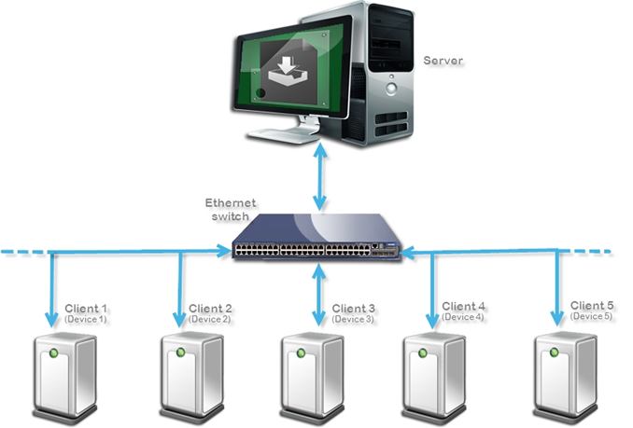
Figure-1: MSU Process Block Diagram

Offer Detailed Requirements

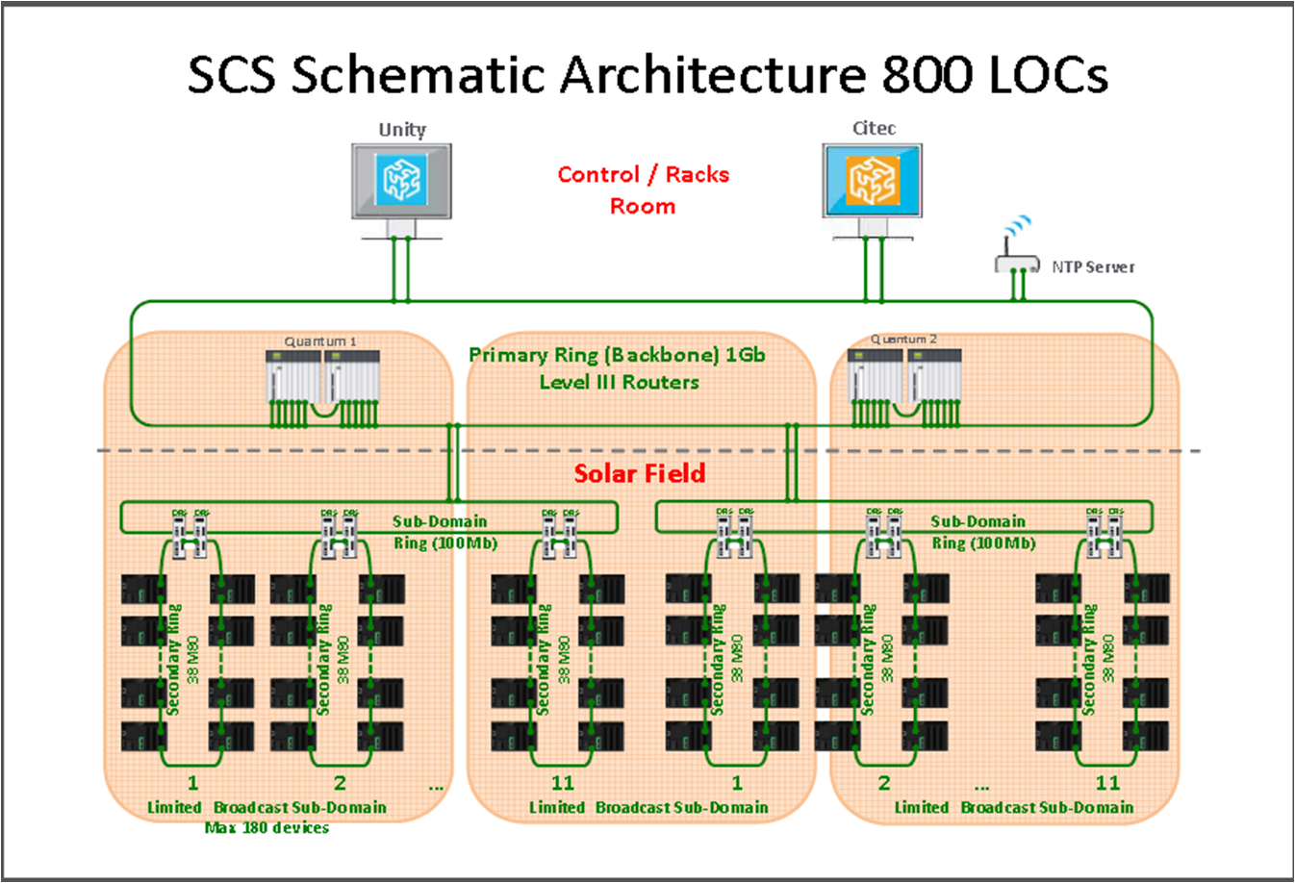
CSP application have large number of devices connected in the network. Such a large network can’t be managed in single network so it is divided into several small networks based on geographic, performance and maintenance. Here is the use case for Mx80 controller for CSP application.
Complete Solar plant divided into many sectors/solar field and each sectors/solar field have many subnets. Each subnet further divided into several rings and one ring can have Max of 38 Mx80 controller. Each subnet can have max 180 Mx80 Controller.
General remarks about Offer Requirements Document
- It is the expression and formalization from the customers needs into offer requirements.
- It corresponds to customer needs to which we have decided to answer.
- It is the project reference that becomes the commitment of the project team.
- Note: the offer is material or immaterial. It includes product, equipment, solutions, systems, and services, provided by the company to satisfy the customer needs.
- The retained requirement should be associated to a means of validation. Therefore it should be measurable and controllable.

In this document the structural MIRs of the Offer functional description are translated into detailed MIRs appropriate to be translated into SRS and linked to Requisite Pro
The Offer requirement document can be initialized during the Investigation and feasibility phase.
The Offer detailed requirements result from the first analysis made during the previous phase (SELECT) by using the “Functional Need Analysis” method and are restricted to the targeted choice corresponding to the selected project scenario.

From the functional analysis derive a precise and unambiguous description by using e.g. Functional Need Analysis method on the targeted choice.

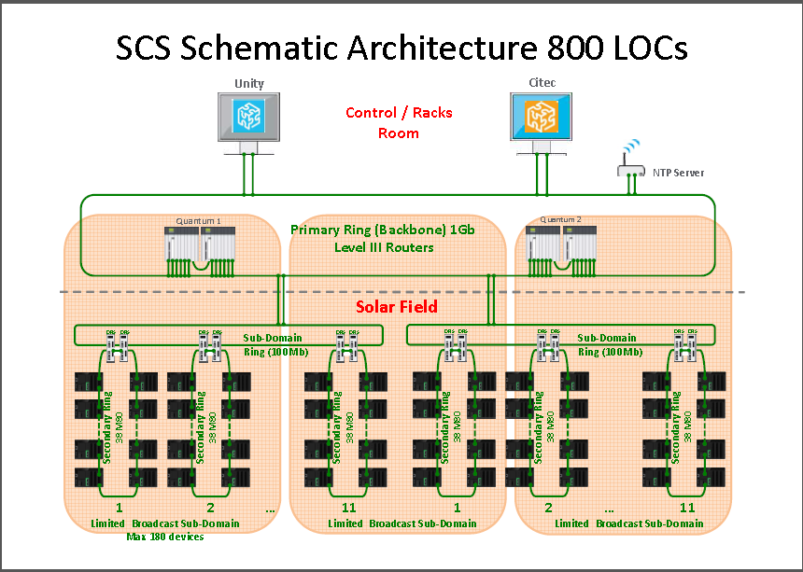

Figure 2: Mass Software upgrade Architecture diagram
Mass Software Upgrade Requirement :
- Device Listing
  - Scan network and list all the devices
  - List all the device according to their H/w type/made type
  - Group the devices as per their hardware type, all similar device/common (binary/application/configuration…) should come in same category
- Device Upgrade preparation
  - Authentication
    - User must have option to select the device from list
    - User must have option to provide authentication( User ID /Password) information for each selected device
    - Authentication level should be configurable at the time network setup (commissioning )
    - Authentication level should @ (common/individual/ not Applicable)
    - Only authentication passed device will be participating in the upgrade process
    - Authentication failed device would be discarded from the process
    - User must know that who are the passed and else are failed in authentication process
  - File selection
    - User must have option to select the file from remote/local system storage
    - MSU must cross check the binary wrt to Hardware. File will appended with predefine header which will use to validate the information
    - If selected file is valid for selected device then only proceed with next process
  - Multiple file selection
    - MSU must provide 4 different type of device upgrade simultaneously
    - MSU must allow to select 4 different files for different device type
- Device Upgrade process
  - MSU must allow selection of device type/group. Can be one or more than one max 4 device type/group at a time.
  - MSU must do file integrity check (CRC) once completely receive at device
  - MSU must provide status for each device who has participated in the current process
  - MSU must provide more detail information/reason for failure device .
- IP white listing
  - MSU must allowed only listed IP to start the upgrade process
  - Every device will have the this list locally
  - Device will validate same with source of upgrade server
- User define command
  - MSU must provide a mechanism to send user define command (e.g. start, stop, run ….)

msu adaptation towards csp application
Prior to filling in this chapter please review the Marketing Consistency rules.
- These rules are general Schneider marketing directives approved by the Consistency Steering Committee (CoSC) and define the general direction for a lot of different topics.
- They are accessible either via OCP Portal http://ocp.schneider-electric.com (Function & Skills: Machines & Process Architectures or http://the-village.schneider-electric.com/Business_Efficiency/Marketing/eLib_Mkt.nsf/vF2/AAFR-6GUFSG?opendocument).
- These rules must be checked and applied.

Other aspects of internal requirements to address in this chapter:
- Brand differentiating requirements
- Platform approach / platforming
- Technical invariants from SCo (Internal specification, Software bricks, reused components & technologies)
- Technical choice for Architecture, Transparent Ready (TR) class, Network connectivity, Interoperability, Safety, CET etc. in detail
- Internal standards (Network policy, Design chart, …)
- Environmental objectives (tool: environmental check list)
- Industrialization requirements which could impact the product design
- Internal requirements from the validated MIR requirements list (MIR coming from other functions than marketing)

With the consideration of a large network retransmission would always be a challenge. AS MSU client sends complain message to server there could be a chance of packet loss and result in more retransmission and finally increase in upgrade process time.
To address same MSU has to limited the number of device to participate in single upgrade process. In a single upgrade process MSU can only handle 253 devices or one subnet ( <253 devices).
MSU provide two solution towards the adaptation of CSP application with consideration of above number of device limitation.
A subnet which have more than 253 devices can be upgraded in multiple upgrade process.
A network which have more than one subnet can be upgraded in multiple upgrade process.
- MSUSingle Tier Architecture : In case we have n subnet (a subnet can have max of 254 device). Consider subnet-1 first and repeat for same until subnet-n is completed
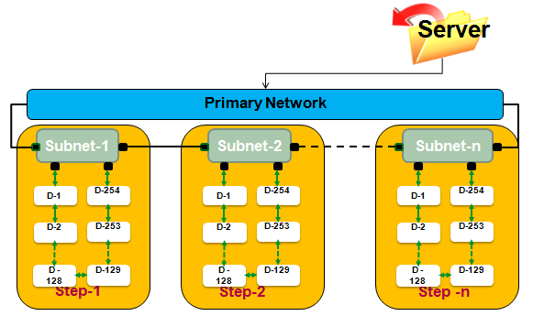
In this case if one upgrade process take 2 min for 2MB of file than n process will take

Total upgrade time = n*2 (Min)

- MSU Two Tier Architecture: This case MSU devices categories into two part first part call MSU master and Second part call MSU Slave. In first upgrade process MSU server will upgrade all MSU master and next upgrade process MSU master will upgrade their own local MSU slave
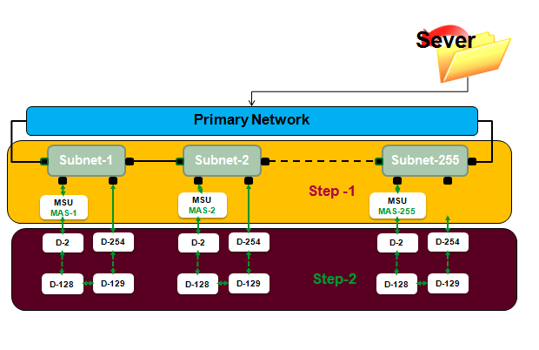

Total upgrade time = 2 * 2 = 4 min

- International standards and norms (UL, IEC, …)
- Legal requirements (CE, …)
- Certification requirements (NEMA, TUF, JIS, …)
- Environmental regulations (European ROHS, WEE, EUP and local regulations)

- Define the functions and features that will be given up and explain the criteria for the decision made and describe the consequences of this withdrawal.
- Provide the list of POSTPONED and REJECTED MIR requirements (renouncements regarding the initial Offer Functional Description) with the possible impact on customer satisfaction and the business case.

